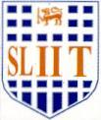
Image Understanding and Processing (OpenCv-Python)

Practical Examination – A
Year 4 Semester 1, 2021

In the given image below, you are required to highlight a specific part of gray level while the rest of the parts in the image are unchanged. You can use an appropriate method to do the task and necessary gray level information is provided.

Intensity level =140 Intensity level = 80

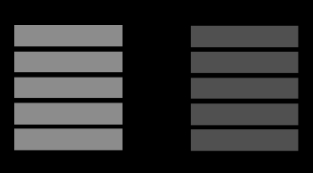 | 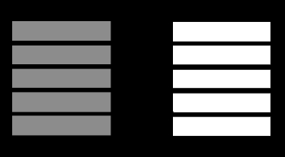

Input Image Output Image

Hint: Use the following transformation function and complete the code below.
Output Intensity Levels
255

0 70 90 255 Input Intensity Levels

